**Create EC2 instance:**

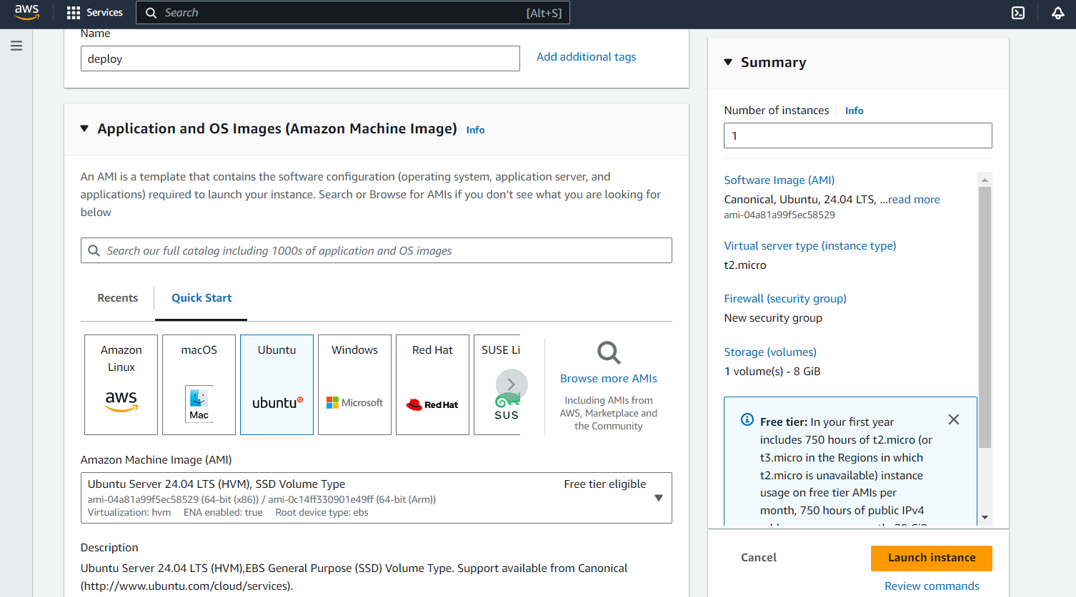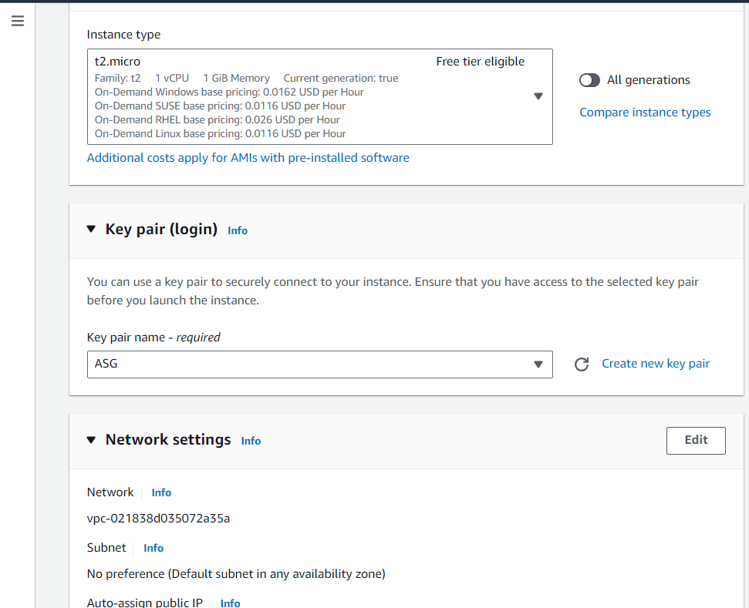

**JENKINS INSTALLATION:**

**Install Java**

sudo apt install default-jdk -y

java -version

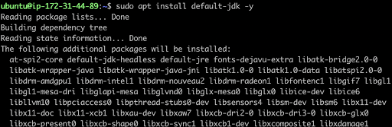

**Maven Installation**

Maven is a popular build tool used for building Java applications. You can install Maven by executing below command:

sudo apt install maven -y

mvn --version

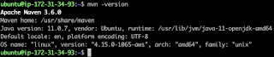

Now lets start Jenkins installation.

**Jenkins Setup**

**Add Repository key to the system**

curl -fsSL https://pkg.jenkins.io/debian/jenkins.io-2023.key | sudo tee \

  /usr/share/keyrings/jenkins-keyring.asc > /dev/null

https://lh7-rt.googleusercontent.com/docsz/AD_4nXd2nWEwWLvjYaW1nzOQIUlaTEJD-9cKE4AgKwfEcZSKzIuU1N8EEiv5SfEWaIVWNRGMLwuNoWDX-PWCShquwvEp2Cweu0V7DYo8jUZEBSEMFp3pYufnSH7x7uIVdEadU6vTbI7Zsose9TYoAFY53hfHF2E?key=CLcQtp8vvlVXb-8Xr4Wzdg

**Append debian package repo address to the system**

echo deb [signed-by=/usr/share/keyrings/jenkins-keyring.asc] \

  https://pkg.jenkins.io/debian binary/ | sudo tee \

  /etc/apt/sources.list.d/jenkins.list > /dev/null

https://lh7-rt.googleusercontent.com/docsz/AD_4nXds5Ty0VNSjkxfDY6P_fMupnfxa35Fn_xMXSYBmop6vW3M9HFIEDsMD5W2fH1far6QKnB7wNEXfx3ti2x9M_nWQ1mc1lOvaMJSb6Jztcjoz-HVxn3emmzxWIx4n9_IYxLkNMCqbGS8TDqK62kVdHwVsA3CC?key=CLcQtp8vvlVXb-8Xr4Wzdg

**Update Ubuntu package**

sudo apt update

**Install Jenkins**

sudo apt install jenkins -y

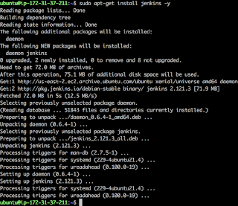

The above screenshot should confirm that Jenkins is successfully installed

**AWS Installation:**

sudo apt install unzip

curl "https://awscli.amazonaws.com/awscli-exe-linux-x86_64.zip" -o "awscliv2.zip"

unzip awscliv2.zip

sudo ./aws/install

aws –version

**Setup Kubectl -**

a. Download kubectl version 1.20  
b. Grant execution permissions to kubectl executable  
c. Move kubectl onto /usr/local/bin  
d. Test that your kubectl installation was successful

curl -o kubectl <https://amazon-eks.s3.us-west-2.amazonaws.com/1.19.6/2021-01-05/bin/linux/amd64/kubectl>

chmod +x ./kubectl

sudo mv ./kubectl /usr/local/bin

kubectl version --short --client

**Setup eksctl**

curl --silent --location "https://github.com/weaveworks/eksctl/releases/latest/download/eksctl_$(uname -s)_amd64.tar.gz" | tar xz -C /tmp

sudo mv /tmp/eksctl /usr/local/bin

eksctl version

**Install docker:**

sudo apt install docker.io

**Giving permissions to jenkins and Ubuntu:**

sudo usermod -aG docker jenkins

sudo usermod -aG docker Ubuntu

sudo systemctl restart jenkins

**From the Jenkins user kubernetes cluster should be installed.**

sudo su – jenkins

aws configuration

so, launching cluster from the Jenkins user:

eksctl create cluster –-name demoapp –-region us-east-1

**Opening port number of Jenkins user:8080**

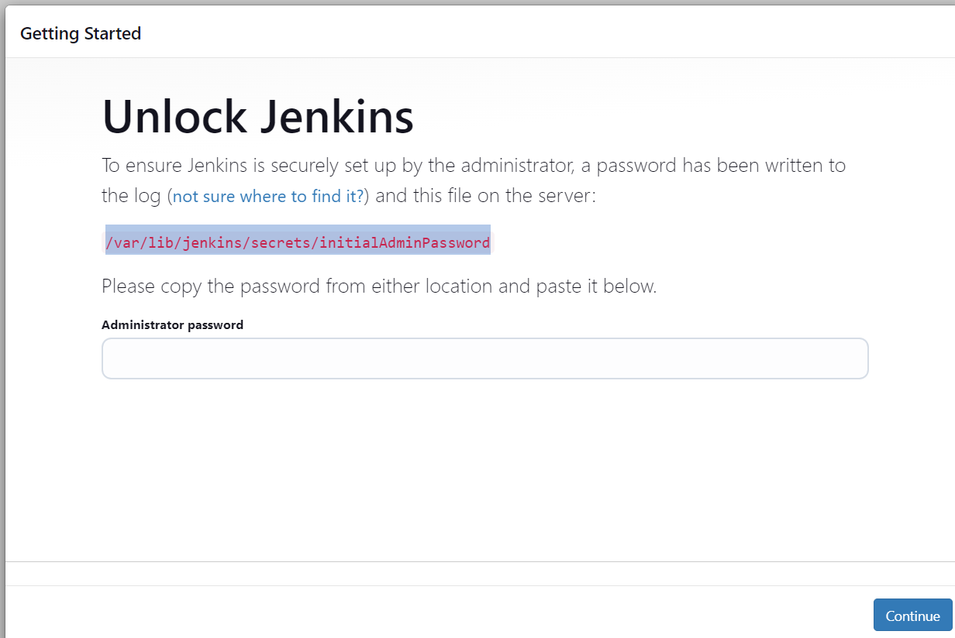sudo cat path= password will be generated

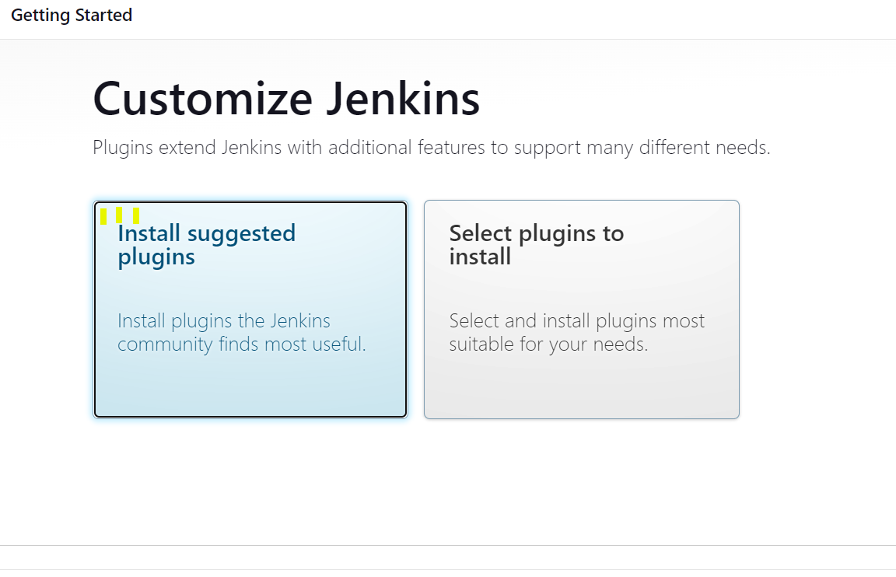 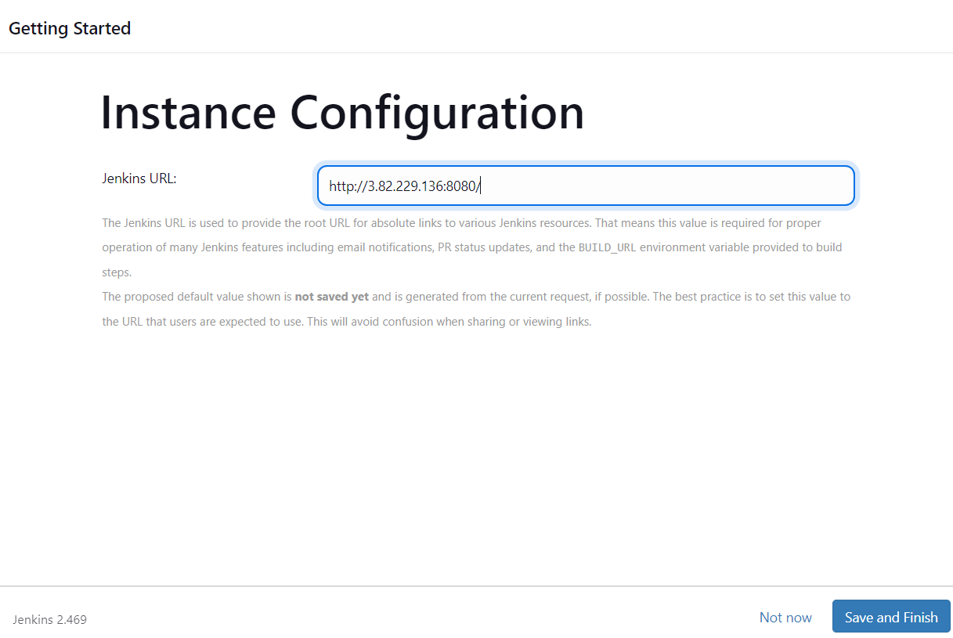

**Create ECR registry:**

With this repository we will be pushing docker image.

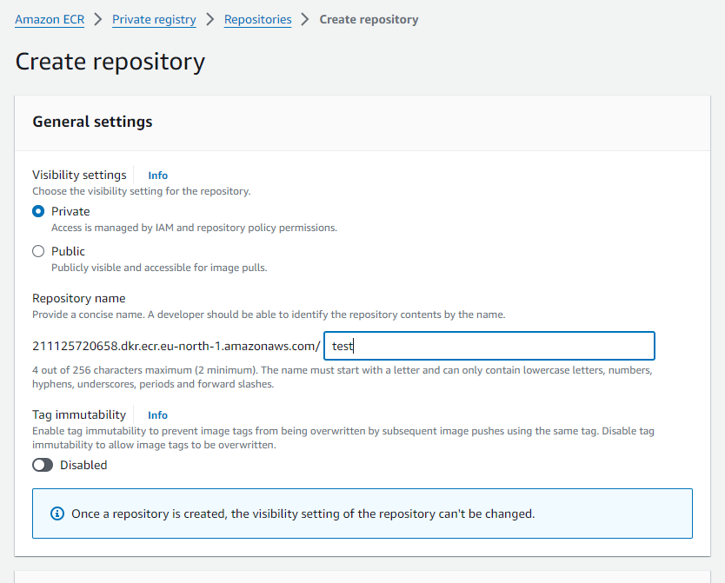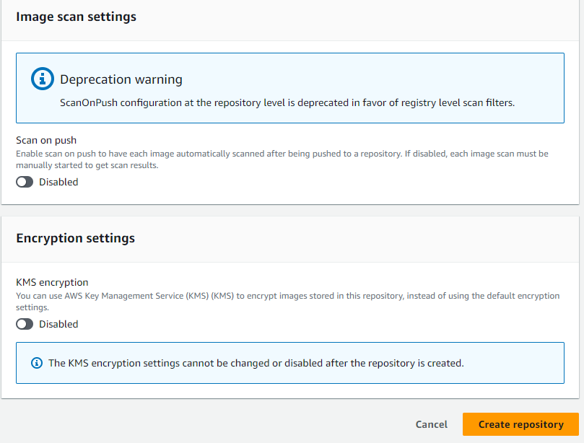

Copy uri of the repository.

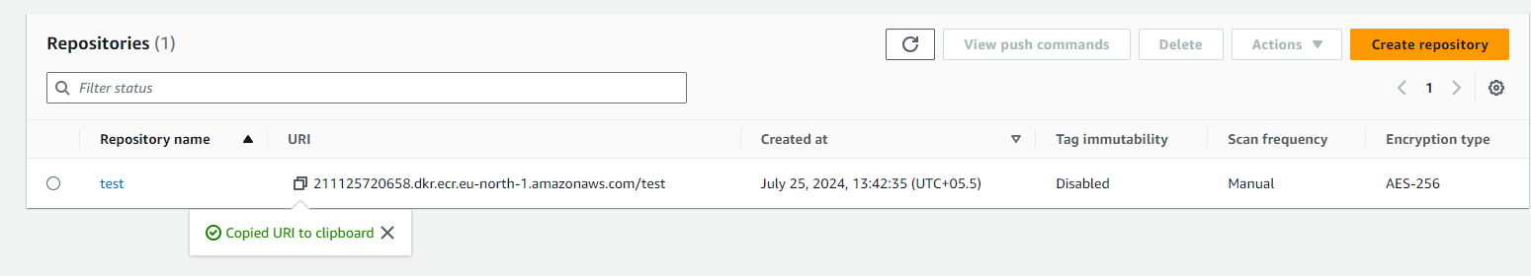

**Job Creation:**

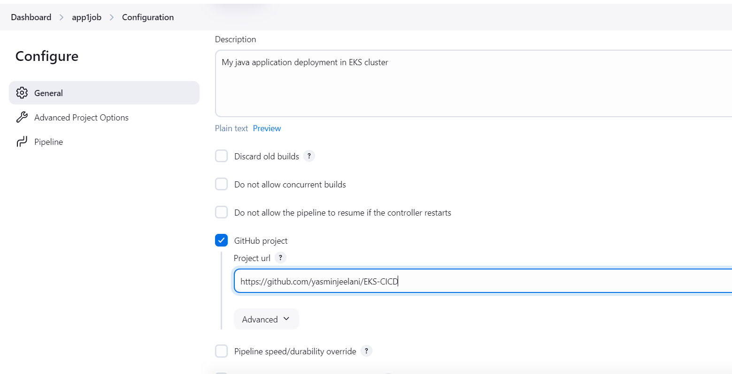

**Creating pipeline:**

**1.Checkout stage:**

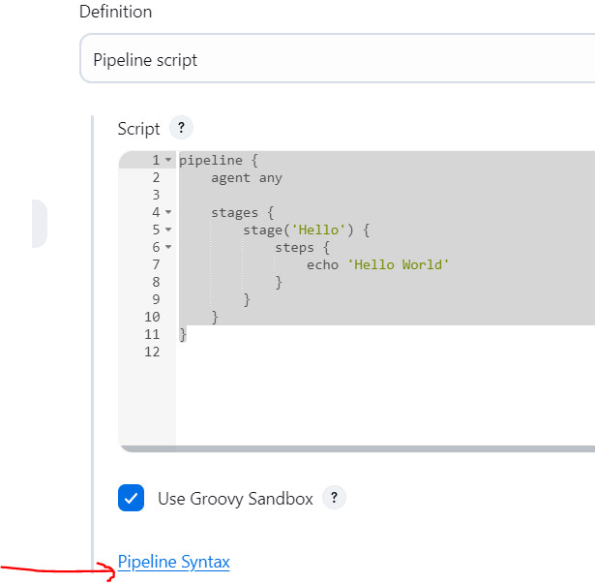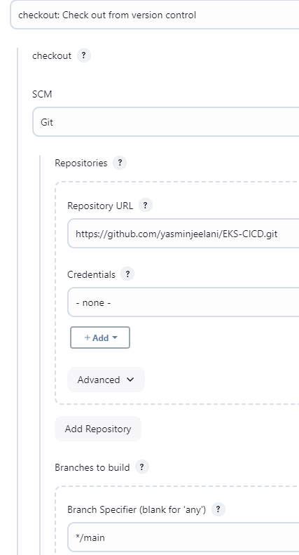

checkout scmGit(branches: [[name: '*/main']], extensions: [], userRemoteConfigs: [[url: 'https://github.com/yasminjeelani/EKS-CICD.git']])

**2.Build stage using maven: maven tool configuration**

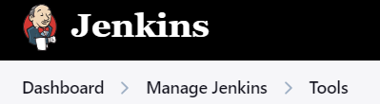

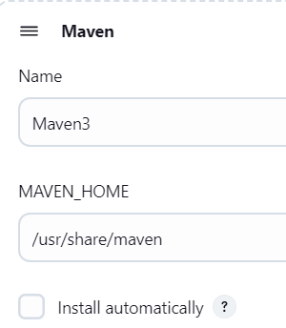

**3.Docker build stage:**

Building docker image by giving registry name

**4. Push Docker image to ECR:**

Docker login and push the docker image to docker hub registry



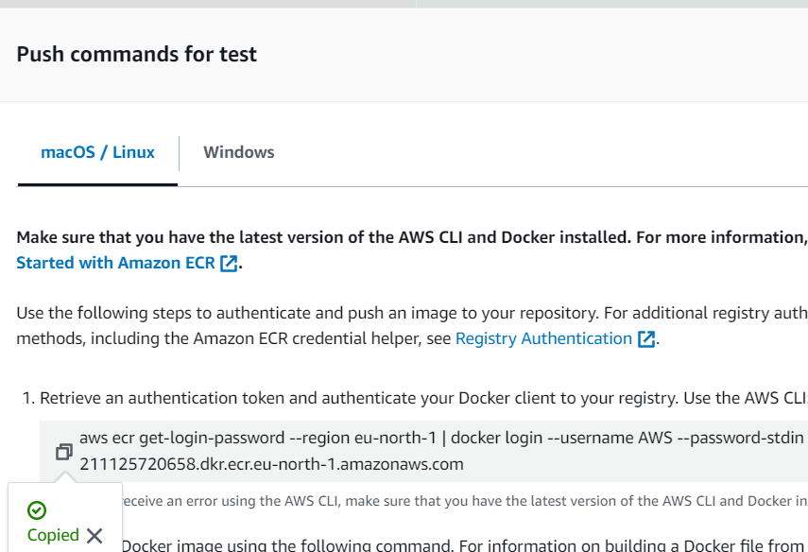

**5. Deploying application to kuernetes cluster stage:**

pipeline {

tools{

maven Maven

}

agent any

environment{

registry= “211125720658.dkr.ecr.us-east-1.amazonaws.com/test”

}

stages {

stage('Checkout Github') {

steps {

checkout scmGit(branches: [[name: '*/main']], extensions: [], userRemoteConfigs: [[url: 'https://github.com/yasminjeelani/EKS-CICD.git']])

}

}

stage('Maven Build') {

steps {

sh ‘mvn clean package’

}

}

stage('Docker Build') {

steps {

sh ‘docker build –t registry’

}

}

stage('Push Docker image to ECR') {

steps {

sh ‘aws ecr get-login-password --region eu-north-1 | docker login --username AWS --password-stdin 211125720658.dkr.ecr.eu-north-1.amazonaws.com’’

sh ‘docker push command’

}

}

stage('KS Deploy') {

steps {

sh ‘kubectl apply –f eks-deploy-k8s.yaml’

}

}

}

}

**Install Plugins before deploy and building**

Docker

Docker pipeline

Kubernetes cli

Aws credentials

**Got authentication error:**

Logging into the kubernetes using jenkins

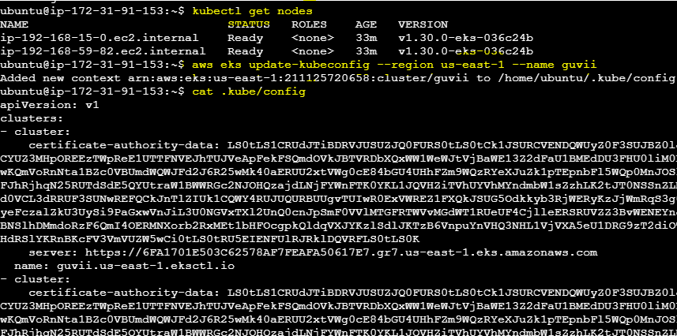

Copy the output and put it in a notepad and upload it in secretfile

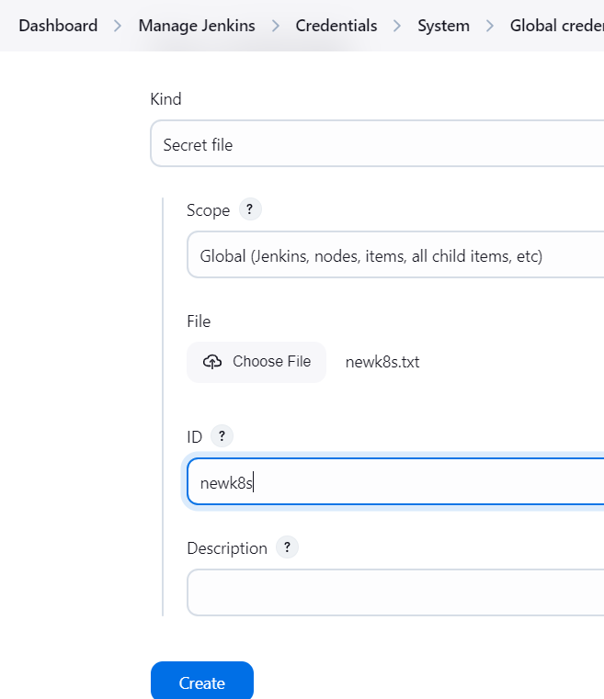

AWS Configuration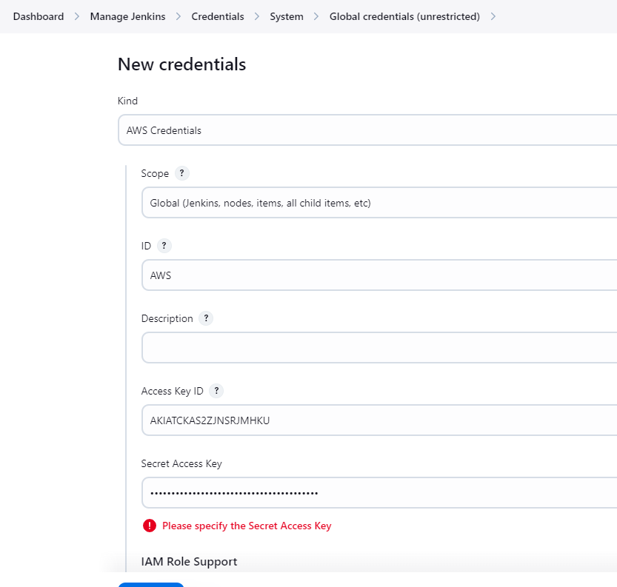



Copy this link and paste it in the below code

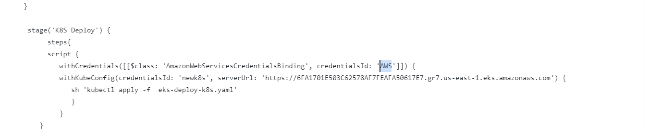

Use this command and get loadbalancer link:

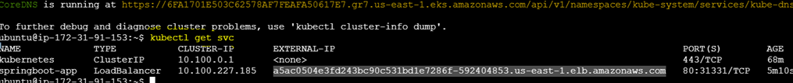

OUTPUT:

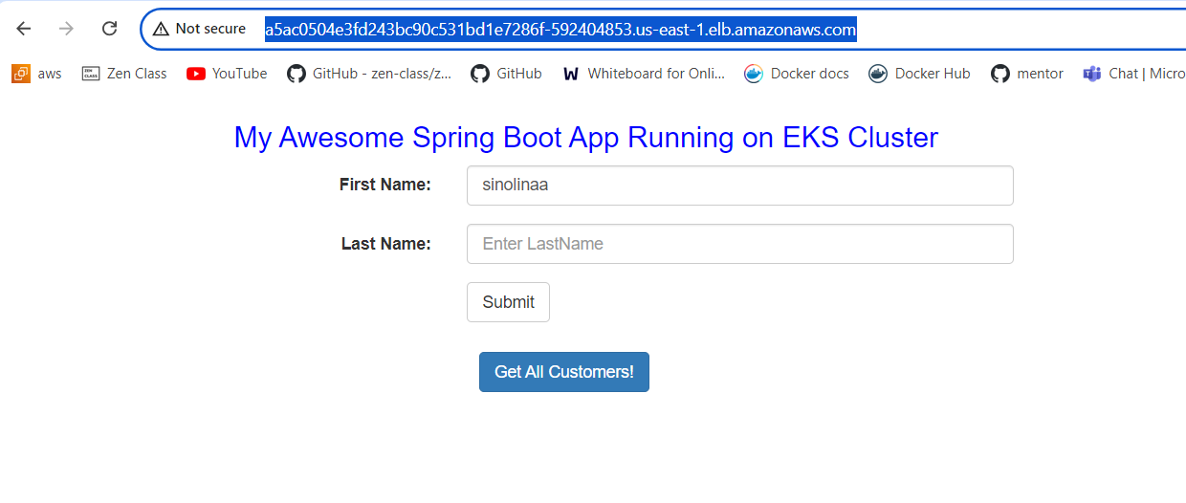

To delete cluser use CLI command or manually delete it and delete everything in cloud formation under stacks